**Tutorial No. 6**

**Problem statement:**

Implement an Expression Evaluator Using Compositedesign pattern.

**Design Assumptions:**

**Composite Design Pattern**

Intent

* Compose objects into tree structures to represent whole-part hierarchies. Composite lets clients treat individual objects and compositions of objects uniformly.
* Recursive composition
* "Directories contain entries, each of which could be a directory."
* 1-to-many "has a" up the "is a" hierarchy

Problem

Application needs to manipulate a hierarchical collection of "primitive" and "composite" objects. Processing of a primitive object is handled one way, and processing of a composite object is handled differently. Having to query the "type" of each object before attempting to process it is not desirable.

Discussion

Define an abstract base class (Component) that specifies the behavior that needs to be exercised uniformly across all primitive and composite objects. Subclass the Primitive and Composite classes off of the Component class. Each Composite object "couples" itself only to the abstract type Component as it manages its "children".

Use this pattern whenever you have "composites that contain components, each of which could be a composite".

Child management methods [e.g. addChild(), removeChild()] should normally be defined in the Composite class. Unfortunately, the desire to treat Primitives and Composites uniformly requires that these methods be moved to the abstract Component class. See the "Opinions" section below for a discussion of "safety" versus "transparency" issues.

Structure

Composites that contain Components, each of which could be a Composite.

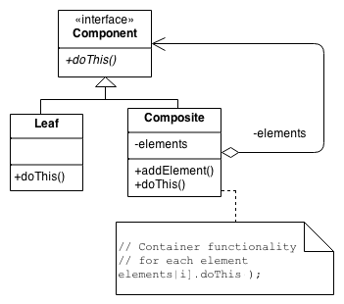

Menus that contain menu items, each of which could be a menu.

Row-column GUI layout managers that contain widgets, each of which could be a row-column GUI layout manager.

Directories that contain files, each of which could be a directory.

Containers that contain Elements, each of which could be a Container.

**Design Diagrams:**

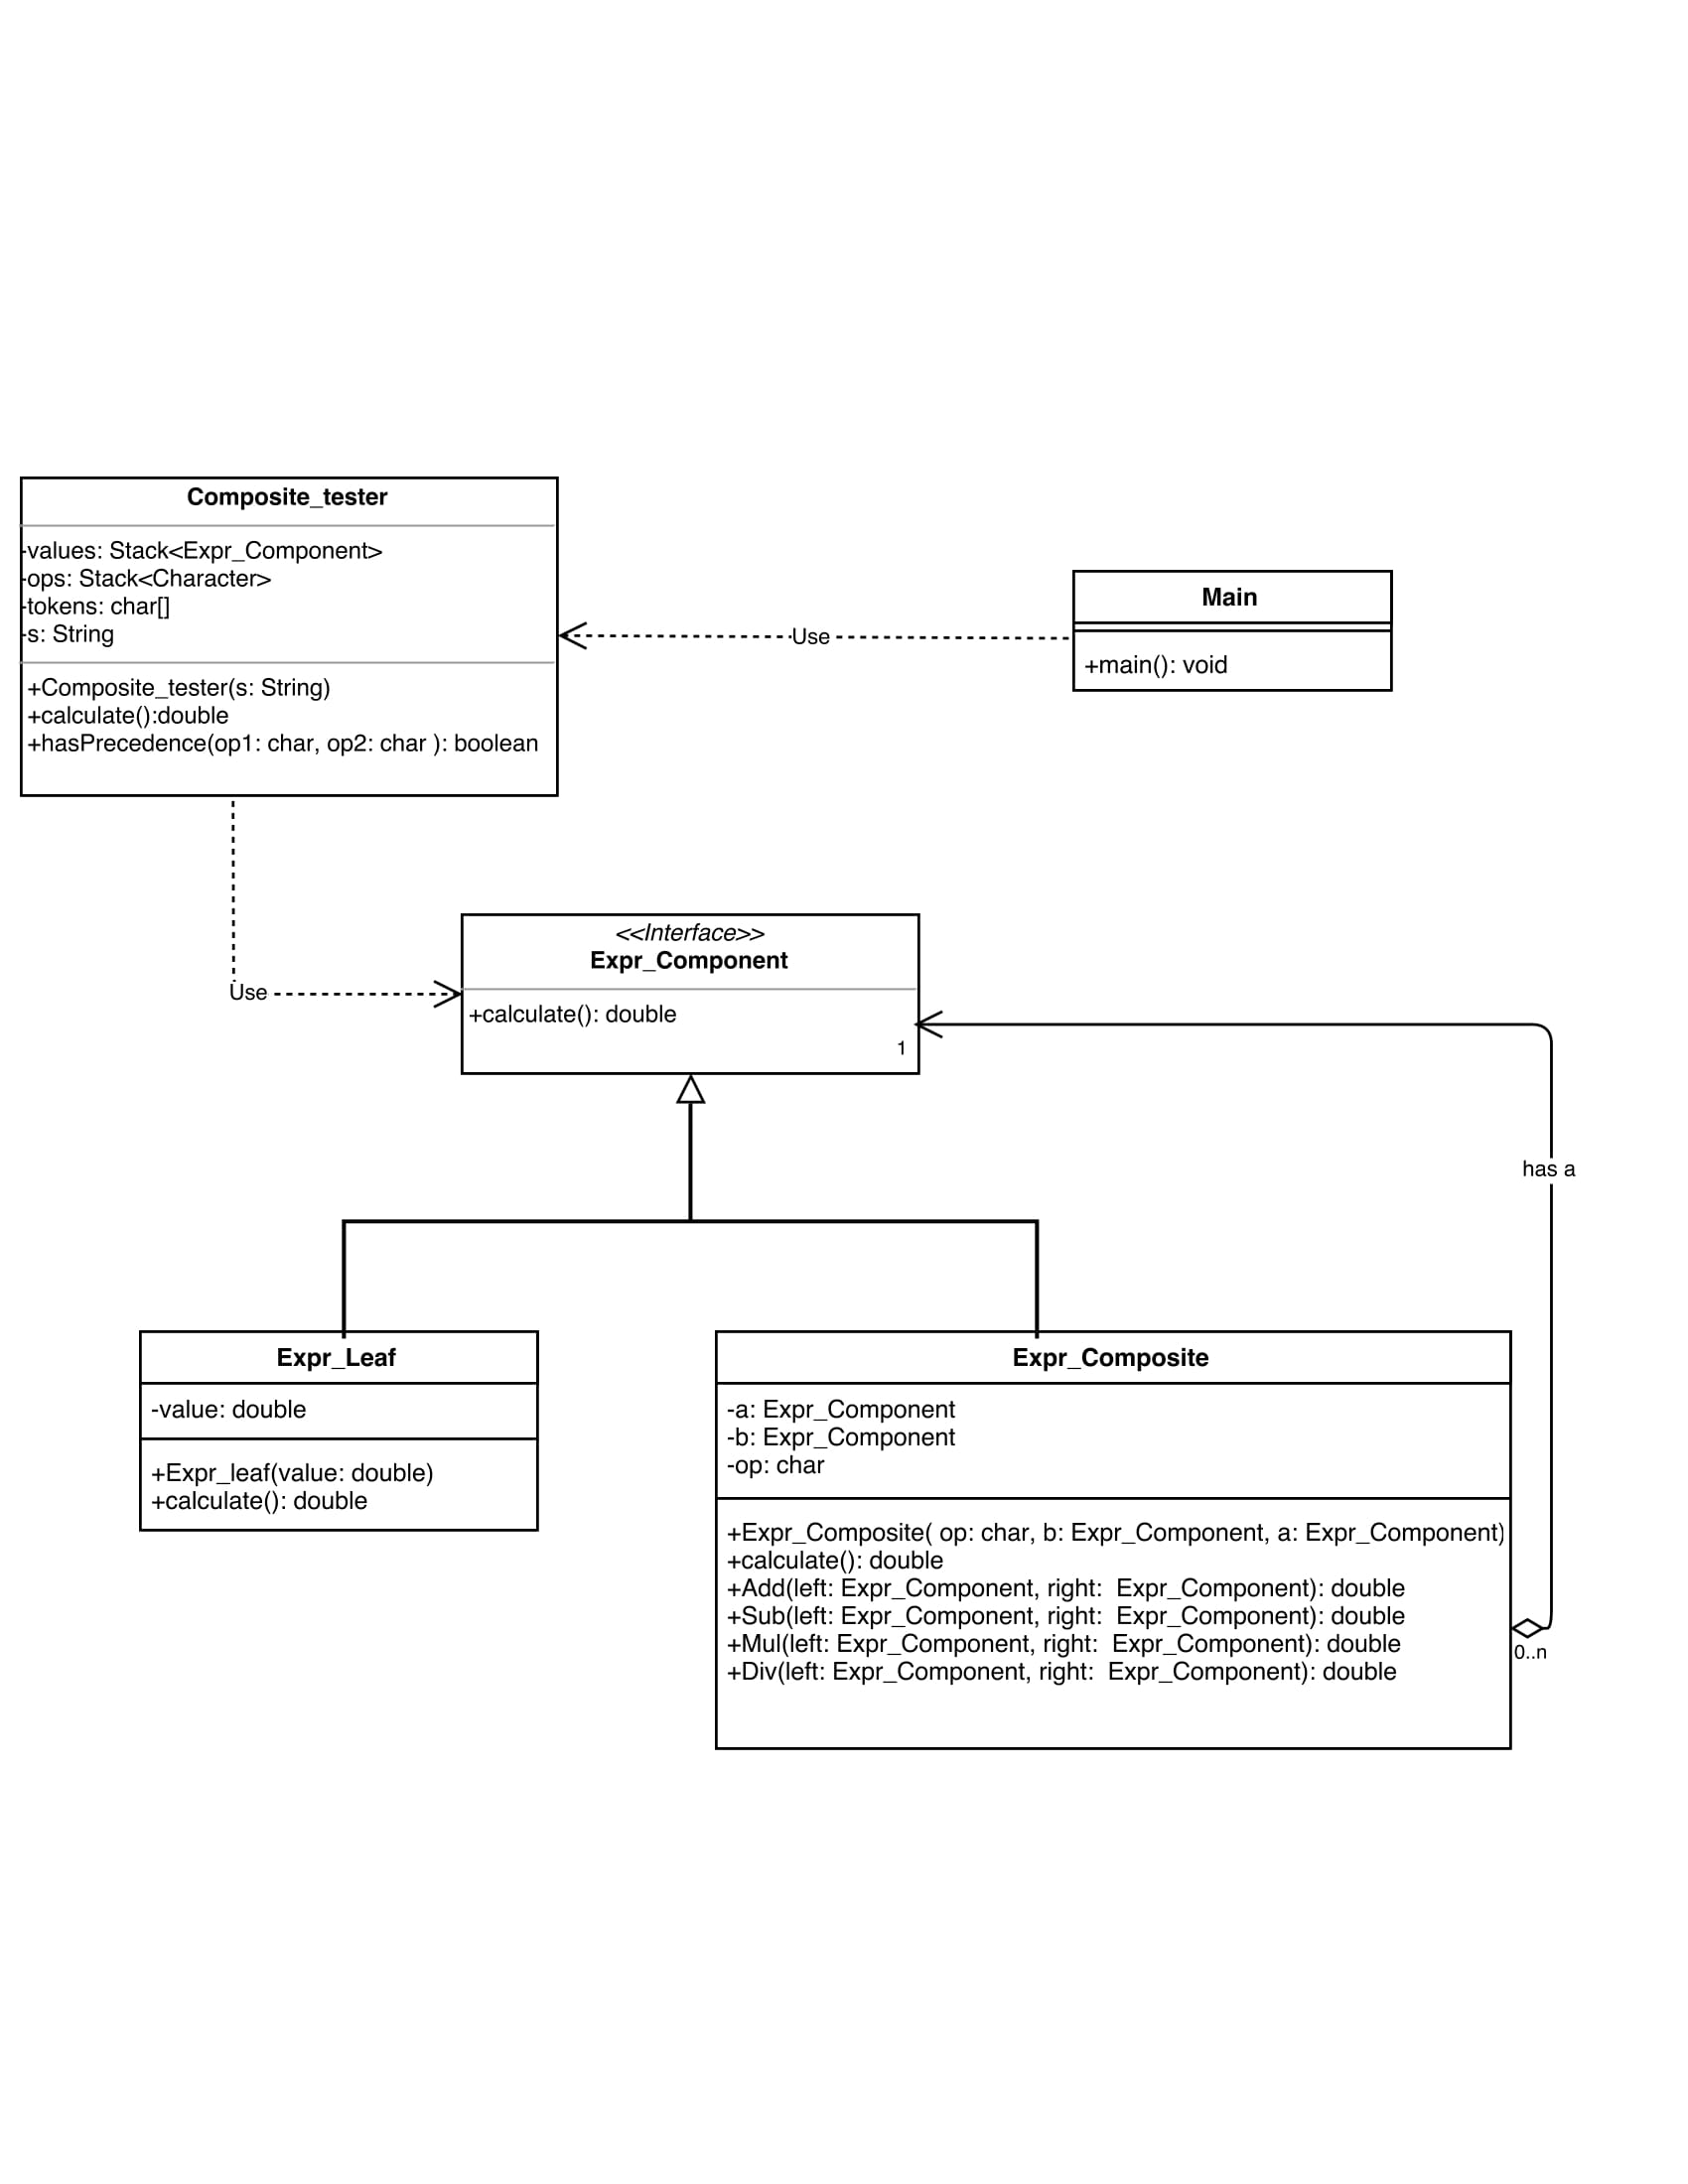

**Code:**

**Composite_tester.java**

************************************************************************

package tutorial.pkg6;

import java.util.Stack;

/**

*

* @author Jatin

*/

public class Composite_tester {

private Stack<Expr_Component> values = null;

private Stack<Character> ops = null;

private char[] tokens = null;

private String s="";

public Composite_tester(String s){

this.s=s;

}

public double calculate(){

tokens = s.toCharArray();

values = new Stack<>();

ops = new Stack<>();

for (int i = 0; i < tokens.length; i++){

if (tokens[i] == ' ')

continue;

if ((tokens[i] >= '0' && tokens[i] <= '9') || (tokens[i]=='.')){

StringBuffer sbuf = new StringBuffer();

while (i < tokens.length &&((tokens[i] >= '0' && tokens[i] <= '9') || (tokens[i]=='.')))

sbuf.append(tokens[i++]);

i--;

values.push(new Expr_leaf(Double.parseDouble(sbuf.toString())));

}

else if (tokens[i] == '+' || tokens[i] == '-' || tokens[i] == '*' || tokens[i] == '/'){

while (!ops.empty() && hasPrecedence(tokens[i], ops.peek()))

values.push(new Expr_leaf((new Expr_Composite(ops.pop(), values.pop(), values.pop())).calculate()));

ops.push(tokens[i]);

}

}

while (!ops.empty())

values.push(new Expr_leaf((new Expr_Composite(ops.pop(), values.pop(), values.pop())).calculate()));

return (values.pop()).calculate();

}

public static boolean hasPrecedence(char op1, char op2)

{

return !((op1 == '*' || op1 == '/') && (op2 == '+' || op2 == '-'));

}

}

**Expr_Component.java**

************************************************************************

package tutorial.pkg6;

public interface Expr_Component {

public double calculate();

}

**Expr_Composite.java**

************************************************************************

package tutorial.pkg6;

import java.util.Stack;

public class Expr_Composite implements Expr_Component{

private char op;

private Expr_Component a;

private Expr_Component b;

public Expr_Composite( char op, Expr_Component b, Expr_Component a){

this.a=a;

this.b=b;

this.op=op;

}

@Override

public double calculate(){

switch (op)

{

case '+':

return Add(a,b);

case '-':

return Sub(a,b);

case '*':

return Mul(a,b);

case '/':

return Div(a,b);

}

return 0;

}

public double Add(Expr_Component left, Expr_Component right){

return left.calculate() + right.calculate();

}

public double Sub(Expr_Component left, Expr_Component right){

return left.calculate() - right.calculate();

}

public double Mul(Expr_Component left, Expr_Component right){

return left.calculate() * right.calculate();

}

public double Div(Expr_Component left, Expr_Component right){

if (right.calculate() == 0)

throw new

UnsupportedOperationException("Cannot divide by zero");

return left.calculate() / right.calculate();

}

}

**Expr_leaf.java**

************************************************************************

package tutorial.pkg6;

public class Expr_leaf implements Expr_Component{

double value;

public Expr_leaf(double value) {

this.value = value;

}

@Override

public double calculate() {

return value;

}

}

**Main.java**

************************************************************************

package tutorial.pkg6;

/**

*

* @author Jatin

*/

public class Main {

public static void main(String[] args) {

System.out.println( String.format("%.2f",(new Composite_tester("5+6*9")).calculate()));

}

}

**Observation:**